|  |  |  |  |  |
| --- | --- | --- | --- | --- |
| • • | G o to fi leftunctior | | | • Addirs • |
| 34 S.R X df.R X | 3rd.R x | | | Untitled3• |
| Source on Save | •J | | |  |
| mean_val | i ], na. rm = TRUE) | | |  |
| uCis.   1. - 2. pri nt (u)   15   1. C, "ozone"] 2. y=uC, "solar. R"] 3. ml <ml   20 #i ii)  21  22  (Top Level) :  Console Background Jobs  R4.2.2  Liu -4 Z.AZYSI | <- mean_val | | |  |
| 151 14. 00000 191 14. 3 |  | 9 | 28 |  |
| 152 18. 00000 131 8.0 | 76 | 9 | 29 |  |
| 153 20. 00000 223 11. 5 |  | 9 | 30 |  |

> x=uC, "0zone"J

> y=uC, "s01ar.R"J > ml<-

cal l :

Im(formula

coeffici ents : (Intercept)

23. 73051 o. 09883

> plot(x, y, main " Air Qual icy" ab "'ozone", ylab

Untitled? x

|  |  |  |  |  |  |  |  |  |  |  |
| --- | --- | --- | --- | --- | --- | --- | --- | --- | --- | --- |
| Air Quality   |  |  |  |  |  | | --- | --- | --- | --- | --- | | 0 90 c9a  00 0 0 | 0 | o | o  8 | 0 00 | | o  c, |  |  |  |  |   50 100 150  Ozone |

|  |
| --- |
| Environment |

-+Run

" sol ar")

raject: (No

2rd.R xHistory Connections Tutorial

Im.ort Dataset

Environment •

|  |  |  |
| --- | --- | --- |
|  | 146 obs. | of 6 |

List of 12 variables

|  |  |
| --- | --- |
| Val ues |  |
| mean_val | 42. 1293103448276 |
| mi ss i ng_values | Named num Cl:6J 37 7 0 0 O O num [1:146] 41 36 12 18 23 |

|  |  |
| --- | --- |
|  | int |

[1:146] 190 118 149 313 299 99 19 194 256 290

R Script : Files Plots Packages Help Viewer Presentation

Zoom Export • O Publish •

warning message:

In 1 m. fit(x, Y' offset offset, singular. ok si ngular.ok extra argument 'ul' will be disregarded

12

1. # which was the coldest day during the period?
2. cal dest_day -c— whi ch. min(ai rpual ityfiemp)
3. ai r qual i ty [cal dest_day , 

15

17 # HOW many days was the wind speed greater than 17 mph?

135 21 259  12

28 238 13

1. 2414
2. 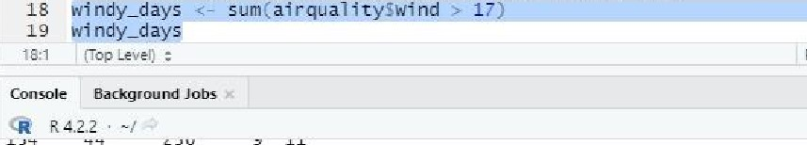112 15



v

I

|  |  |  |  |  |
| --- | --- | --- | --- | --- |
| 13g |  | 237 | g | 16 |
| 140 | 18 | 224 | g | 17 |

13 18

142 24 238 143 16 201

|  |  |  |  |  |
| --- | --- | --- | --- | --- |
| 144 |  | 238 | g | 21 |
| 145 | 23 |  | g | 22 |
| 146 | 36 | 130 |  | 23 |
| 147 |  |  | 9 | 24 |
| 148 | 14 | 20 |  | 25 |
| 144 | 30 | 193 | g | 26 |
|  |  | 14 s | g | 27 |
| 151 | 14 |  |  | 28 |

1. 18 131
2. 20 22330

> col dest_day which. min(ai it)ÆTemp)

> rquality (col dest_day,) ozone solar. R 1%'ind Temp r•tonth DAY

56

> wi ndy_days sum(airqual i tySwind > 17)

> wi ndy_days

1

2 1 brary(dplyr)

1.  <-airqual ity

|  |  |  |  |  |
| --- | --- | --- | --- | --- |
| 146 -36. 00000 | 10. | 81 | 9 |  |
| 147 7 . 00000 |  | 69 | 9 | 24 |
| 148 14. aoooa | 20 16. 6 |  |  | 25 |
| 149 30. ooooa |  | 70 | 9 | 26 |
| 150 42,12931 | 145 1-3. 2 | 77 |  |  |
| 151 14. ooooa | 191 14. | 75 | 9 | 28 |
| 152 18. ooooa | 131 B. | 75 | 9 | 29 |
| 153 00000 | 223 11. 5 | 58 | 9 | 30 |

1. 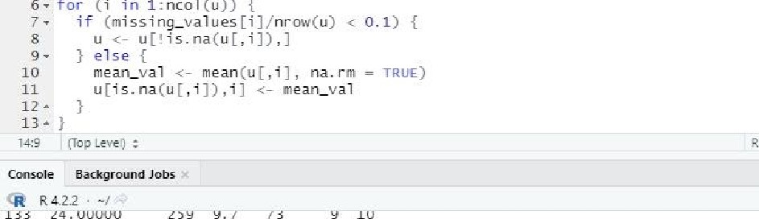mi ssi ny_val UE-E -z- c01Sums(i s. na(u)) for (i in I:ncol (u)) {

24 . UUtJt.JU

|  |  |  |  |  |  |  |
| --- | --- | --- | --- | --- | --- | --- |
| 134 | 44 ooooa | 2 -36 | 14. s | 81 |  | 11 |
| 133 | 21. ooooa | 259 | 15. 5 | 75 | 9 | 12 |
| 136 | 28. ooooa | 238 | 6. 3 | 77 | 9 | 13 |
| 137 | 9. 00000 | 24 | 10.9 | 71 | 9 | 14 |
|  | . 00000 | 112 | 11. 5 | 71 | 9 |  |
|  | 00000 | 237 | 6 | 78 | 9 |  |
| 140 | 18. 00000 | 224 | 13.8 | 57 |  |  |
| 141 | . 00000 | 27 | 10. | 76 | 9 | 18 |

1. 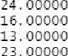238 10.
2. 201  82  20
3. 12. 54  21
4. 14  71 9 22

pj BAS.R / df.R x Untitled'* x Untitled2V x 2nd.R * Environment History Connections Tutorial

A SourceonSave —4 Run 'mpart Dataset • J • 137 MiB • List

13 t cast(tl, Month + Day — vari abl e) R • Global Environment •

14

Data

|  |  |  |
| --- | --- | --- |
|  | 153 obs. | of 6 variables |

16 €2=cast (CI , Month—Day , mean)

17

O 612 obs. of 4 variables

153 obs. of 6 variables

14:1 (Top Level) : R Script

Console Background Jobs

R 4.2.2

189 4. 6

7.4

6 92 15. 5 Files Plots Packages Help Viewer Presentat ion

252 10. 9 Install Update

220 10. 3 

Name Description Version

230 10. 9

9 10 259 9. 7 System Library

9 11 236 14. 9

9 12 259 15. 5 base The R Base Package 4.22 9 13 238 boot Bootstrap Functions (Originally by Areo Canty for S) 1.3-28

9 14 24 10. g

9 15 112 11. 5 Functions for Classification 7.3-20

9 16 46 237 6. 9 Helpers for Developing Command Line Interfaces 3.6.o

9 17 224 13. 8

cluster "Finding Groups in Data": Cluster Analysis Extended 2.1ß 9 18 27 10. 3

Rousseeuw et al.

9 238 10. 3

9 20 201 8. 0 82 codetools Code Analysis Tools for R 0.2-18

9 21 238 12. 6 compiler The R Compiler Package 42.2

9 22 14

139 10. 3 cow' lot Streamlined Plot Theme and Plot Annotations for 1.1.1

9 23

9 24 10. 3 'gg plot?

9 25 20 16. 6 data.table Extension of 'data.frame' 1.14.6

9 26 193 6. 9 datasets The R Datasets Package 4.22

9 27 145 13. 2

9 28 191 14. 3 dplyr A Grammar of Data Manipulation 1.0.10

9 29 131 8. 0 76 fansi ANSI Control Sequence Aware String Functions 1.0.3

9 30 223 11. 5

foreign Read Data Stored by 'Minitab', 'SAS', 'SPSS', 'Stata', 0.8-83

M odé.;:



1

1. 1 i br ary(reshape
2. t=ai r qual i ty

4 

5

6

Min. I.oo 1st Qu. . • 18.00 Median : 31. 50

Mean : 42.13 3rd Qur : 63.25

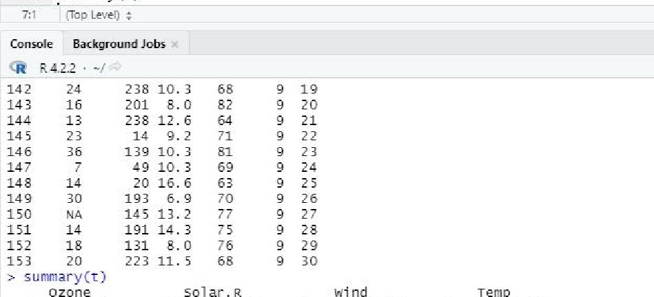

summary

(t)

Temp

Max. :168. oo

Month

yin.7.0 Min. . 1. 700 yin.

1st Qu. :115. 8 1st Qur : 7 . 400 1st Qu. : 72.00 Medi an : 205.O Median : 9.700 Medi an 173.00 v e an :185.  Mean : 9.958 mean :77. 88 3rd Qu : 258. 8 3rd Qu :11. 500 3rd Qu. 185.00  : 334O MAX. : 20. 700: 97.00

 ' s 

|  |  |  |
| --- | --- | --- |
| Min. | : s. 000 | Yin. . 1.0 |
| 1st Qu | 000 | 1st Qu • 8.0 |
| Median | . 000 | yedi an |
| Mean |  | yean :15. s |
| 3rd Qu | 000 | 3rd Qu. : 23.0 |
| max. | : 9. 000 | Max. : 31. o |

Day

BASR XCintitIed3* Y

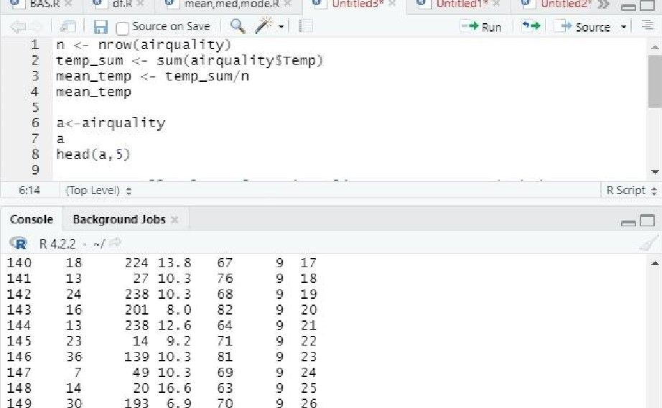

Script:

150

14

5

13.2

77

!

LjSourceonSeve

# nrow(airquality)

1. temp_sum gum (ai r
2. mean=temp temp_sum/n

30 193 70 9 26

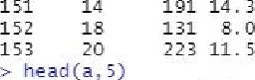 14. 3 75  28

76 9 29

68

Ozane sa 1 ar. R Wind Temp t•tonth 

1. 41 190 714 67 5 1
2. 72 5 2

  12 74 5 

4 1862 5 4

56 5 

# > n nrow(airquality)

> temp_sum sum(airqyal itysvemp)  mean_temp temp_sum/n > mean—temp 1 77.

1

2 80, go, 20)  mean(a)

4 medi an(a) 5 mode=f u i on ()

1. .
2. return(names (sort

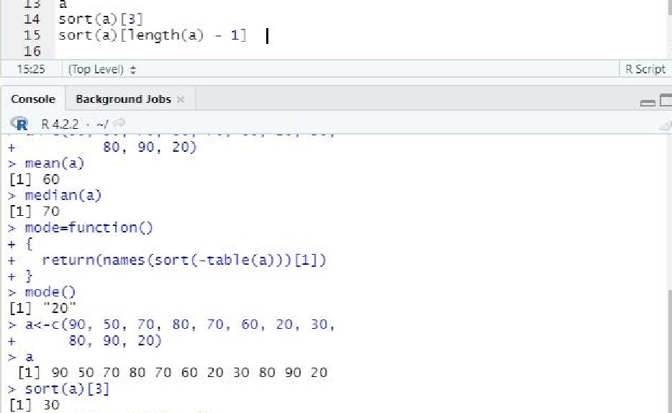

13

>

sort

(a)

L

length(a)

-

11

1

go



x

x

df.R

Untftledl*

Untitkd2'

9 modeO

10

1.  70, 80, 70, 60, 20, 30,
2. 80, go, 20)



16

 BAS R Sf.R

S headCa, 5)

10

11 Airquality[, ! (names (airqual ity) cc "Temp" , "wind")) ]

12

1. # which was the coldest day during the period? which. min(ai rc;ual ityfiemp)

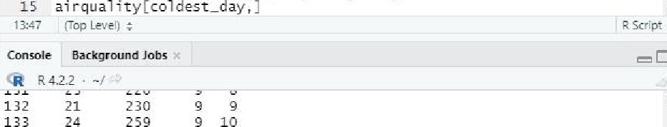

14

coldest_day

1. 21 230
2. 24 259

|  |  |  |  |  |
| --- | --- | --- | --- | --- |
| 134 | 44 | 236 | g | 11 |
| 135 | 21 | 259 |  | 12 |
| 136 | 28 | 238 |  | 13 |
| 137 |  | 24 |  | 14 |
| 138 | 13 | 112 |  | 15 |
| 139 |  | 237 | g | 16 |
| 140 | 18 | 224 |  | 17 |
| 141 |  | 27 | g | 18 |
| 142 | 24 | 238 |  | 19 |
| 143 | 16 | 201 | g | 20 |
| 144 |  | 238 |  | 21 |
| 145 | 23 | 14 | g | 22 |
| 146  147 | 36 |  |  | 23  24 |
| 148 | 14 | 20 | g | 25 |
| 149 | 30 | 193 |  | 26 |
|  |  | 14 s | g | 27 |
| 151 | 14 | 191 |  |  |
| 152 | 18 | 131 |  | 29 |
| 153 | 20 | 223 |  | 30 |

# > coldest _day whi ch. min(airqual ity$Temp)

> ai r quality Lc01desz_daY'J ozone solar. R wind Temp Month

56